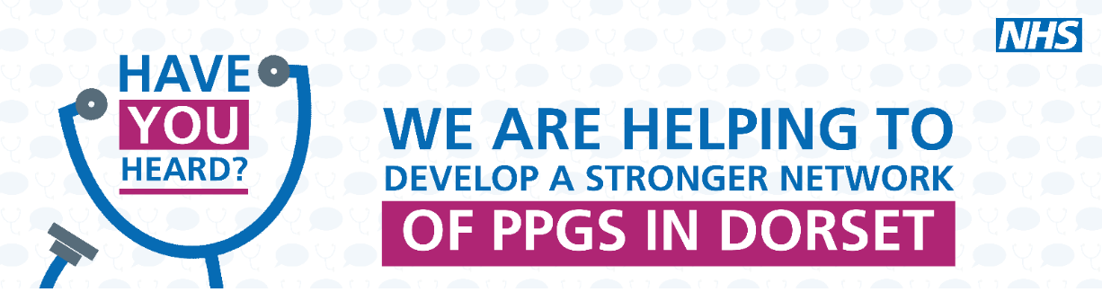
Bridges Patient Participation Group (PPG)
20 September 2022
Zoom

Notes of Meeting
 |  | Action
1 | Welcome and apologies  Present: Sue Brunt (Chair), Dr Karen Kirkham, Lennie Edwards, EO, NW, MB, Jim Gammans (ICB)  Apologies: FK, SE, GC
2 | Surgery update  Flu clinics –  Flu clinics are starting on Saturday 1 October. Patients are being sent a link by text to book an appointment. Those who are unable to receive a text will be sent a letter advising them of walk-in times.  Over 65s will be done 1st and then under 65s from 15 October.  Covid vaccines –  The practice is no longer involved in arranging the Covid clinics. Patients need to go online or phone 119.  There was discussion about the lack of local appointments. Jim will speak to his colleagues to see what the availability is.  Post meeting note: New vaccination slots on the National Booking System (NBS) are available every Monday. The Linden unit is looking to increase capacity.  Marathon –  Dr Ed Beedham is running the marathon in London and Louise Bell is running it in Weymouth at the same time. They are raising money for Blood Cancer UK. If you would like to donate, you can search Edward Beedham on the Just Giving website or hand your donations to reception if you prefer cash.  Staff Changes –  Dr Karen Kirkham is sadly retiring from the practice at the end of the month. The group expressed their sincere thanks to Karen for her 28 years of being a dedicated, caring GP. Karen said it had been a privilege being a family Dr in an amazing practice.
3 | Minutes of the last meeting  Enhanced Access  The PCN’s plan has been approved by the ICB. Although due to start in Oct it will take time to implement. As most surgeries are doing their flu clinics on Saturdays they can be counted in the requirement of 1 hour per 1,000 patients before 8am, after 6:30pm or weekends.  Website  The times of the Digital Volunteer sessions have been amended.  Deputy Chair  No one has expressed an interest in the role. If anyone is interested, please contact Sue.
4 | Newsletter  The practice will aim for the Autumn edition to be published by the end of September.  EO said she doesn’t get the texts with the link although she does get other texts from the surgery. Lennie doesn’t know why this is the case but will look into it. | Lennie to look into why EO doesn’t get the newsletter text.
5 | Action Plan  The group discussed the outstanding actions. The “Tip sheet” for patients for getting the most out of consultations still needs to be acquired from Crescent Street. It will be included in a future newsletter.  JO and SE have offered to sense check newsletters and texts (time allowing) before they are published.  The Digital Volunteers have helped 332 patients across the PCN since June; 100 at Bridges and 50 at Littlemoor. They have had positive feedback and Sue has been asked to speak to other PCNs and the Council. The practice will continue to send texts advertising the sessions. The volunteers are also helping patients set up the BP at Home app which is a great way to manage Hypertension.
6 | Food Bank  The group agreed not to keep this as it was felt the surgery wasn’t the best place for it.
7 | AOB  Sue and Jim are meeting with the local community pharmacy lead. There was discussion about the lack of Pharmacists and how it’s impacting on their service to patients. Jim said commissioning for pharmacies will move from NHS England to the ICB next year. We hope to work with the pharmacies – Lennie suggested they have the surgeries bypass numbers to they can phone directly instead of the patient having to and being ‘stuck in the middle’. A future newsletter could be dedicated to explaining how the prescription process works and encouraging patient not to stockpile as millions of pounds are wasted each year.
Close
Next meeting TBA

